Here are the formulae that I have created from the rules as sent by Lucy.

IF(TSC="F",ROUND_UP(0.33*Value 29,1),IF(TSC="A",ROUND_UP(IF(((1.58*Value 29)+(0.7*Case total number(Product))+7)<(2*Case total number(Product)),(2*Case total number(Product)),(1.58*Value 29)+(0.7*Case total number(Product))+7),1),IF(TSC="Z",ROUND_UP(IF(((2.02*Value 29)+(0.5*Case total number(Product))+9)<(2*Case total number(Product)),(2*Case total number(Product)),(1.58*Value 29)+(0.7*Case total number(Product))+7),1),99999)))

- Re-name planogram description field 30 to TSC

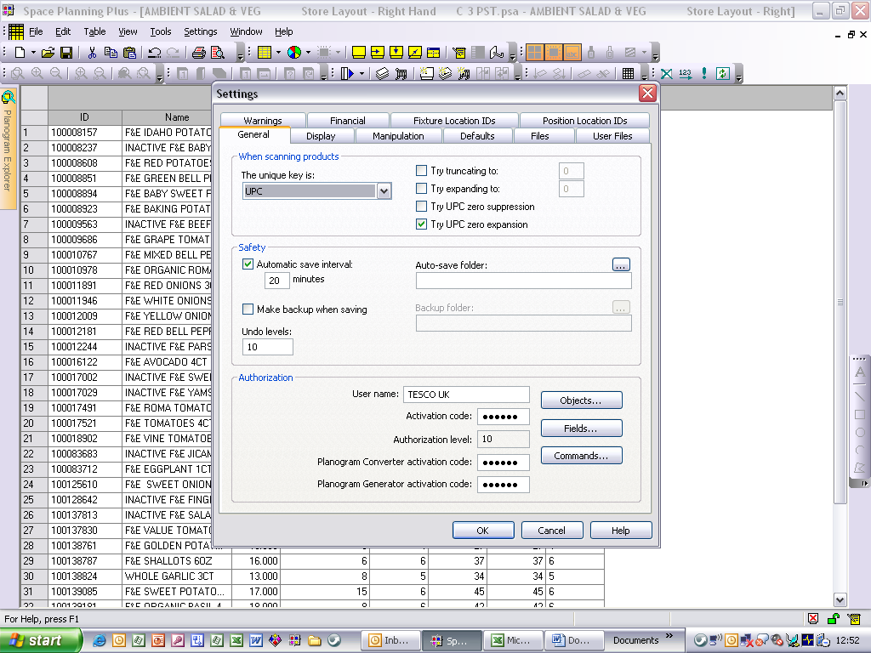

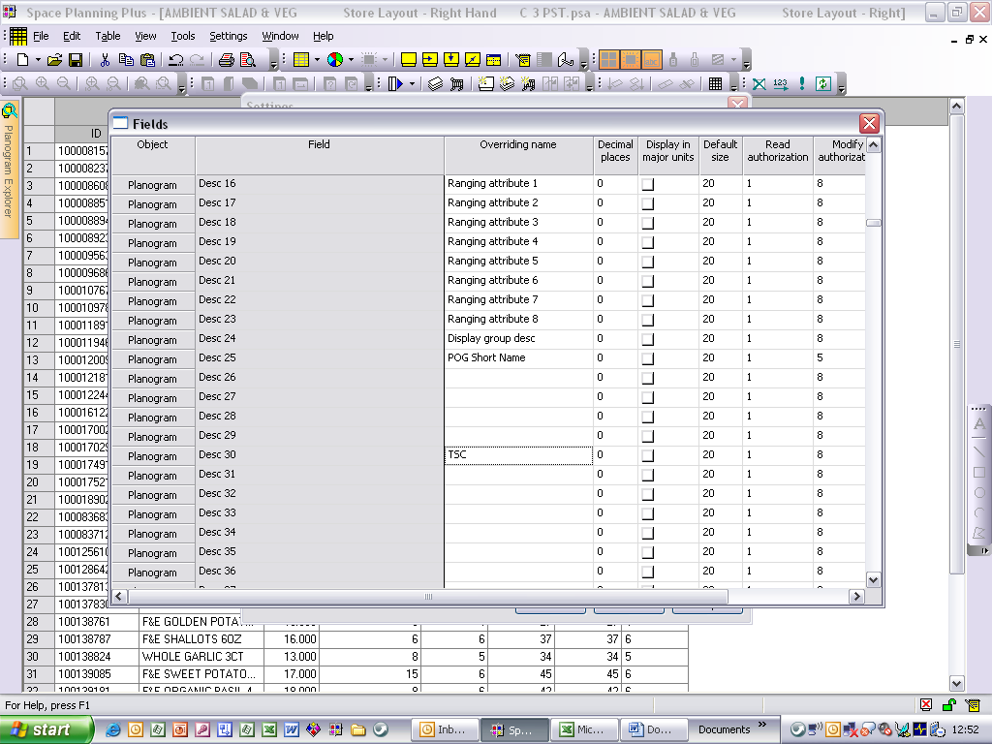

- Input override calculation

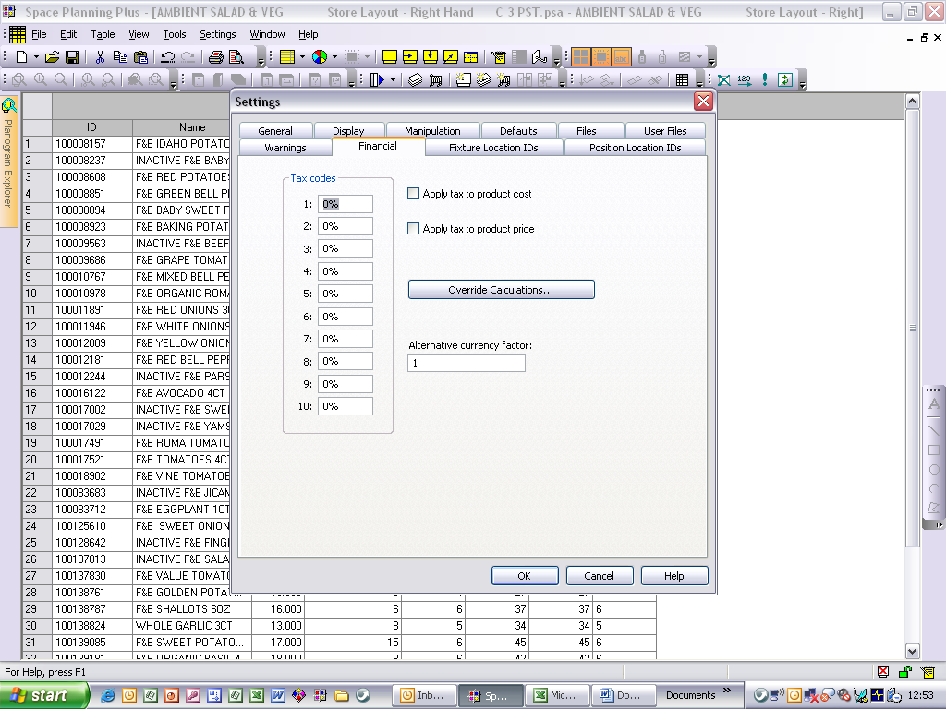

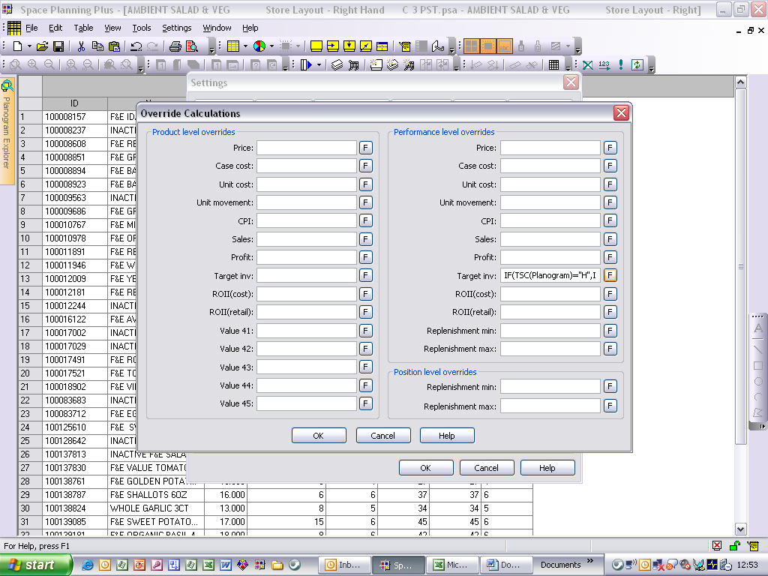

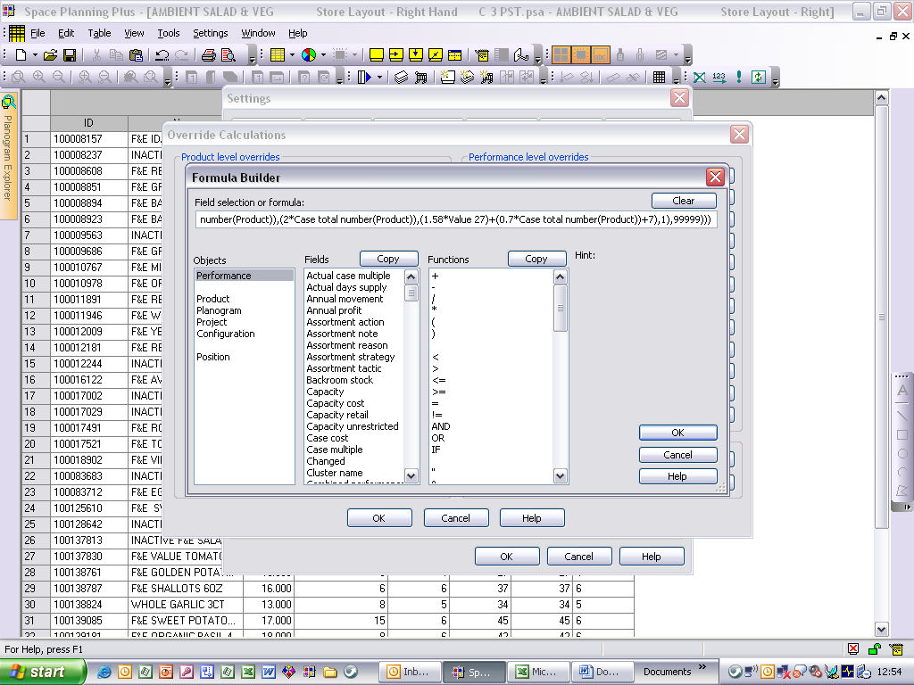

3. Once this has been configured the values F (for fresh), A for Ambient) or Z (for Frozen) will need to be held against planogram description 30 (which has been re-named to TSC) to select the appropriate target capacity rule

Here is the breakdown of the formula so that if you need to change any of the values you can.

Fresh rule : 33% of a current Week's Sales

IF(TSC="F",ROUND_UP(0.33*Value 29,1),

Ambient rule: 79% of 2 weeks sales + 70% of a Case Pack + 7 Singles (or 2 cases whichever is greater)

IF(TSC="A",ROUND_UP(IF(((1.58*Value 29)+(0.7*Case total number(Product))+7)<(2*Case total number(Product)),(2*Case total number(Product)),(1.58*Value 29)+(0.7*Case total number(Product))+7),1),

Frozen rule: 101% of 2 weeks sales + 50% of a Case Pack + 9 Singles (or 2 cases whichever is greater)

IF(TSC="Z",ROUND_UP(IF(((2.02*Value 29)+(0.5*Case total number(Product))+9)<(2*Case total number(Product)),(2*Case total number(Product)),(1.58*Value 29)+(0.7*Case total number(Product))+7),1),99999)))

